**ST. XAVIER’S COLLEGE**

**(Affiliated to Tribhuvan University)**

**Maitighar, Kathmandu**



**SIMULATION AND MODELING LAB REPORT #05**

**SUBMITTED BY:**

Pradeep Dahal

017BSCIT029

3rd year/ 5th Sem

|  |  |
| --- | --- |
|  | Signature |
| Mr. Ganesh Yogi  (Lecturer) |  |
| Department of Computer Science | |

**SUBMITTED TO:**

**TITLE: TO FIND THE VALUE OF PIE BY MONTE-CARLO METHOD IN EXCEL.**

**THEORY:**

For Monte Carlo, simply define a rectangle that encompasses your function between the specified limits. Then generate uniform random pairs of numbers and scale them to fit as a point inside that rectangle. Count the number of points under the curve and divide that by the total number of points, multiply that ratio by the area of the rectangle, and the result will be the Monte Carlo estimate of the area under the curve.

For the calculus answer, simply integrate the function and apply the limits (value of the integral at the upper limit minus value of the integral at the lower limit).

**RESULT:**

**Range for x and y:**

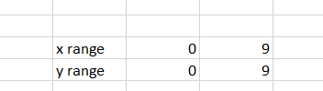

**Value of n and N:**



**Random values:**

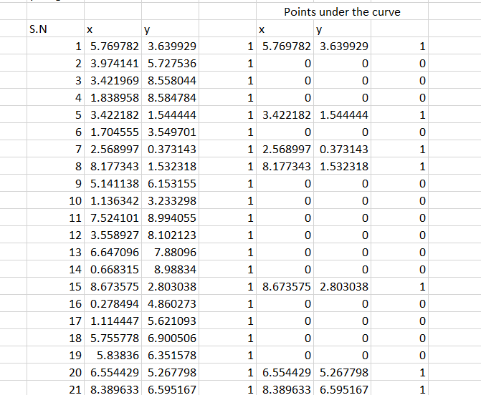

**Points under rectangle:**

For x, the formula in the excel sheet is given by:

=$B$2+(($C$2-$B$2)*RAND())

For y, the formula in the excel sheet is given by:

=$B$3+((-$B$3+$C$3)*RAND())

**Points under curve:**

For x, the formula in the excel sheet is given by:

=IF(C6<B6,B6,0)

For y, the formula in the excel sheet is given by:

=IF(C6<B6,C6,0)

**Value area obtained by monte carlo and the actual area:**

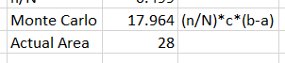

**CONCLUSION**

Hence, the actual area of the curve is found to be 28 whereas from the monte carlo method the area of the curve is found to be 17.964.